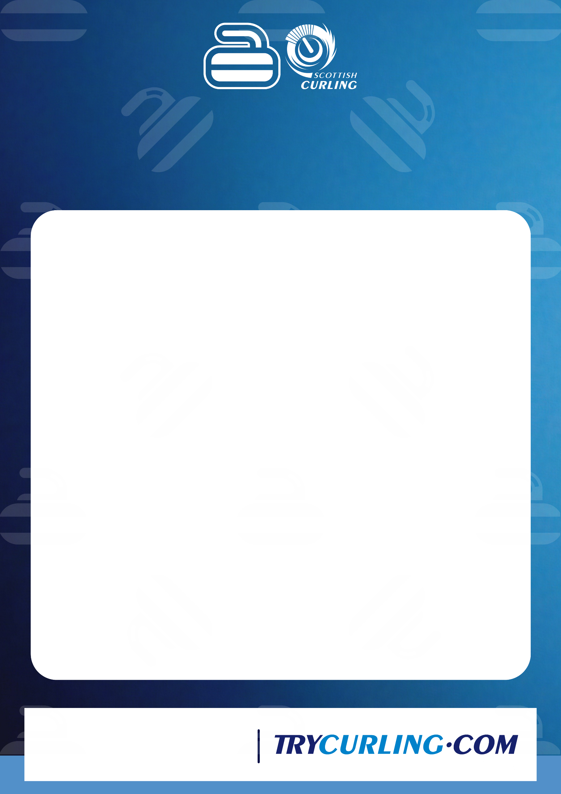
INSERT DETAILS OF YOUR BEGINNER SESSIONS HERE, INCLUDING DATE, TIME, LOCATION & COST ETC.

INSERT YOUR OWN TEXT ABOUT YOUR BEGINNER SESSIONS HERE

Beginner Curling

